AIR QUALITY MONITORING

Phase 1:problem definition and design thinking

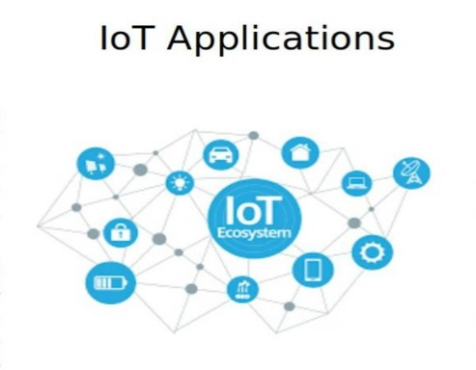

TEAM LEADER:DINESH BOOPATHY C

TEAM MEMBER:DANUSH P

TEAM MEMBER:SUNIL KUMAR P

TEAM MEMBER:JAYAKUMAR

Air quality monitoring is the systematic and coordinated approach to assessing, regulating, and improving the quality of the air in a specific region or area. It involves monitoring air pollutants, setting standards and regulations, implementing strategies to reduce emissions, and educating the public about air quality issues. The primary goal is to protect human health the environment by minimizing the presence of harmful air pollutants and maintaining air quality at levels that are safe for people to breathe.

**Program statement**

in the context of software development, is a written description or document that outlines the purpose, objectives, and functionality of a software program or application. It serves as a blueprint for developers, designers, and stakeholders, providing a clear understanding of what the software is intended to achieve.

A typical program statement includes:

1. **Objective:** A clear and concise statement of the program’s goals and what it aims to accomplish.
2. **Scope:** An outline of the features, functions, and capabilities that the program will include. This defines the boundaries of the project.
3. **Requirements:** Specific technical and functional requirements, including any hardware or software dependencies.
4. **User Stories:** If applicable, descriptions of how the software will be used from the perspective of different types of users.
5. **Functional Flow:** A high-level overview of how the program will function, including key processes and interactions.
6. **Data Model:** A description of the data that the program will use or generate, including databases or data structures.
7. **User Interface Design:** If relevant, mock-ups or descriptions of the user interface, including screen layouts and navigation.
8. **Testing and Quality Assurance:** Plans for testing the software to ensure it meets its requirements and functions correctly.
9. 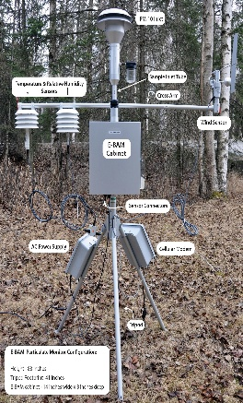**Timeline and Milestones:** A rough estimate of the project’s timeline, including major milestones and deadlines.

The program statement serves as a reference point throughout the software development process, helping all stakeholders stay aligned and focused on the project’s objectives. It can also be used to evaluate the success of the completed software against the initial goals and requirements.

**Design thinking**

Is a human-centered, problem-solving approach and mindset that is used to create innovative and effective solutions to complex problems. It places a strong emphasis on understanding the needs and perspectives of the people who will use or be affected by the solutions being developed. Here are the key principles and stages of the design thinking process:

1. **Empathize:** This initial stage involves researching and understanding the needs, behaviors, and challenges of the people for whom you are designing. It often includes activities such as interviews, surveys, observations, and immersion in the users’ environment.
2. **Define:** In this stage, you distill the insights gathered during the empathize stage to define the problem or challenge you are trying to solve. It involves framing the problem statement in a way that is user-centric and actionable.
3. **Ideate:** During the ideation stage, you generate a wide range of creative ideas and potential solutions without judgment. Techniques like brainstorming, mind mapping, and sketching are commonly used to encourage creative thinking.
4. **Prototype:** This stage involves creating low-fidelity representations or prototypes of your ideas. Prototypes can be sketches, physical models, or interactive digital mock-ups. The goal is to quickly and cost-effectively test and iterate on your concepts.
5. **Test:** You gather feedback on your prototypes by testing them with real users or stakeholders. This feedback helps refine and improve your solutions. Testing can be an iterative process, and you may cycle back through the stages to make further refinements.
6. **Implement:** Once you have a refined and validated solution, you move into the implementation phase, where you develop and deploy the final product or solution.
7. **Iterate:** Design thinking is an iterative process, and it often involves going back to earlier stages to make improvements based on new insights or changing circumstances.

Key principles of design thinking include:

- **User-Centered:** It focuses on the needs, behaviors, and experiences of users or customers.

- **Collaborative:** It encourages multidisciplinary teams to work together, bringing diverse perspectives to problem-solving.

- **Iterative:** It emphasizes the importance of refining and iterating on solutions based on feedback and testing.

- **Creative:** It promotes creative thinking and ideation to generate innovative solutions.

- **Holistic:** It considers the entire user journey and ecosystem rather than isolated components.

Design thinking is widely used in various fields, including product design, service design, business strategy, and social innovation, to tackle complex and ambiguous problems by placing people at the center of the design process.

